**3. MDQ Products:**

* Also known as **Multi-Dimensional Quoting Products.**
* MDQ is a Subscription type product. We set the Subscription Pricing as a Fixed Price
* To understand the MDQ products let's discuss a use case -  
  **Requirement**-We need to set up the Antivirus quote and the quote term is 1 Year. But if some will purchase it for 5 years then for the first 2 years, we need to give 10% discount and for 3rd year we need to provide 20% discount and after 3rd years we are giving 30% discount.   
  **Steps to Create an MDQ Product-**
  + Click on New in Product and give it a name - MS Antivirus, Give Subscription Term as 1, and Subscription Pricing as Fixed Price, and Subscription Type as Renewable and Check Active checkbox.
  + Save Product
  + Click on Related and under Price Book click on Add Standard Price, Give a Standard Price of 100.
  + Now under Price Dimensions click on the New button. Fill Product, Dimension Name, Type and Unit Price as given in the below screenshot. Also please make sure this Unit Price will override the Price book unit price that we have defined in the above step

[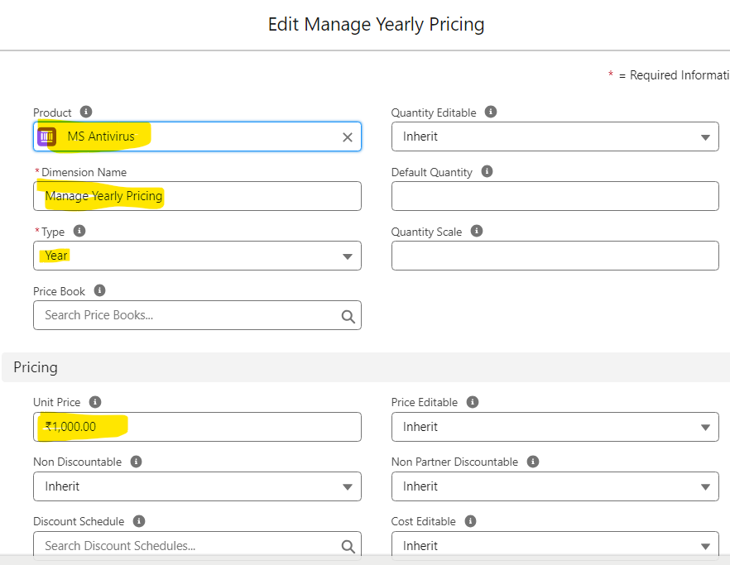](https://www.blogger.com/blog/post/edit/5479395999909322176/3214906548246170862)

* + Click on Save.
  + Edit / Create a new Quote and click on the Edit Line button.
  + It will open the QLE page then click on Add Product button and search for the Product that we created under step 1 that is -  MS Antivirus
  + Select  MS Antivirus Product and Add it to QLE (Select that product by checking the checkbox in front of the Product Code and Click on the Select button)
  + Once Product is added then you will notice a new icon will be shown. This is for Resegment Line Click on it

[](https://www.blogger.com/blog/post/edit/5479395999909322176/3214906548246170862)

* + After clicking you will QLE as -

[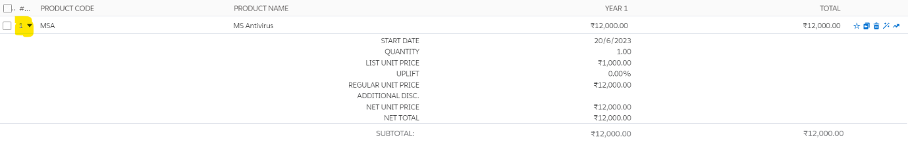](https://www.blogger.com/blog/post/edit/5479395999909322176/3214906548246170862)

* + Now in the Subscription Term give 60 ( Convert 5 years into months that is 12*5 = 60). Click on Calculate button and you will see additional sections will get enabled. Now for each, you can configure the discount. As per the requirement for 1st two years, it is 10% and for 3rd year it is 20% and for the remaining years, it is 30%. After adding the discount click on calculate button again and you will see the Net Price will update according to the discount provided. Click on save and convert the opportunity.

 [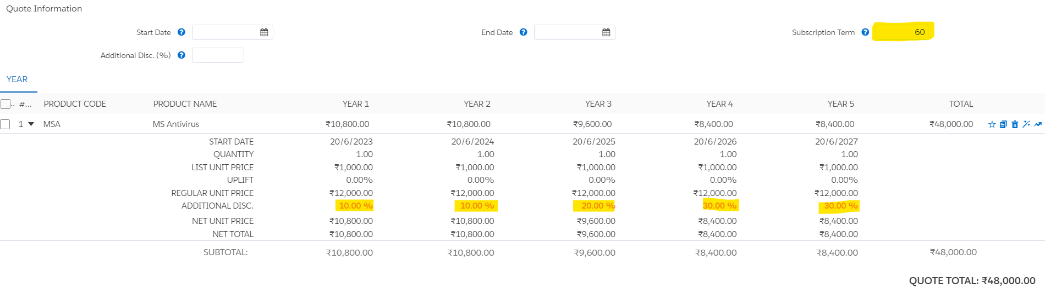](https://www.blogger.com/blog/post/edit/5479395999909322176/3214906548246170862)

**4. Usage-Based Product:**

* These products change based on product consumption. The price of the products will be based on the predefined rates for future consumption of the product.
* For example, your cell phone consumption pricing is based on the amount of data you consume per month. This is a Usage-Based Product.

**5. Product Bundles:**

* Product bundles are a collection of products that are sold together.
* Bundles may include options to choose from; these are like the subproducts. Product options with similar characteristics can be grouped together as features.
* For example, a laptop can be a bundle with a charger and a mouse as its components. Color and memory can be the options to choose from.

**6. Perpetual Products:**

* These products are EMI-based or One-time contracts based, once the contract or EMI is over these become Assets. The price is not prorated.

The major difference is perpetual products can become one-time or several payments can become Assets at last. Perpetual products are part of a Non-subscription only.

[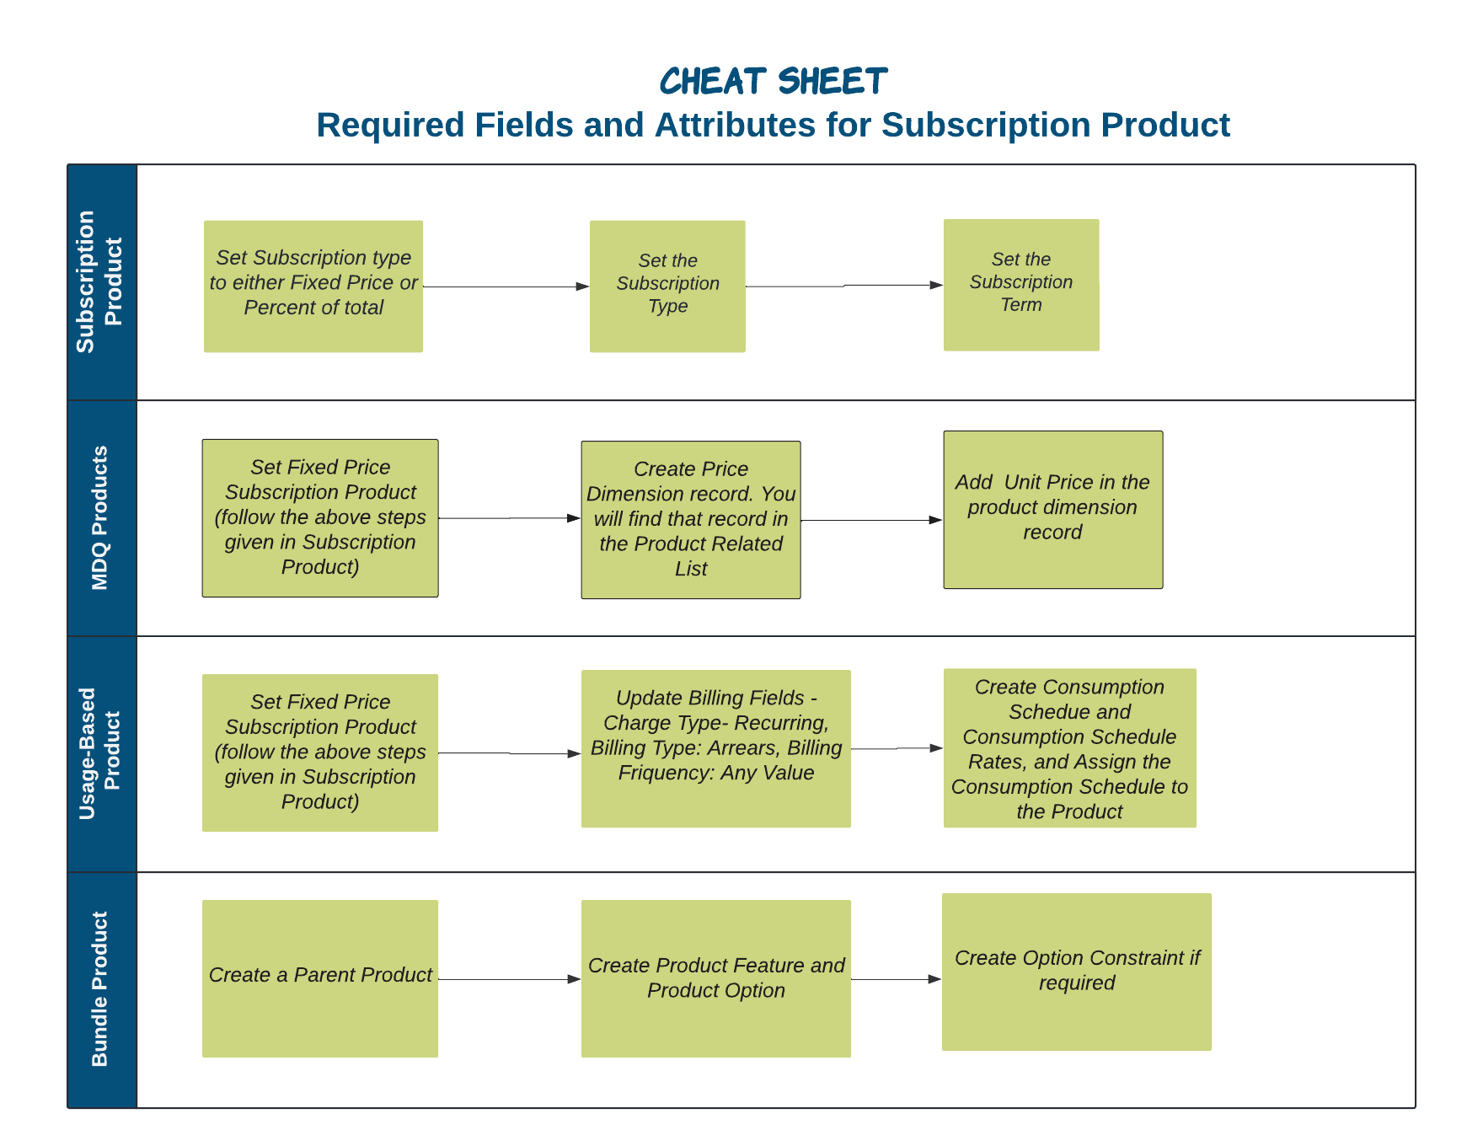](https://www.blogger.com/blog/post/edit/5479395999909322176/3214906548246170862)

Interview Questions -

MDQ Products-

1. What is Multi-Dimensional Quoting (MDQ) in Salesforce CPQ, and why is it important for businesses?
2. Explain the concept of "Dimensions" in MDQ. How do they differ from product options?
3. Can you provide an example of a real-world scenario where MDQ would be used to create a quote?
4. What are the key considerations when designing pricing models and discount structures in MDQ?

Usage Based Products-

1. What are usage-based products in Salesforce CPQ, and why are they important for businesses?
2. How does Salesforce CPQ handle metering and tracking usage for usage-based products?
3. Can you explain the key components (objects involved) of a usage-based product in Salesforce CPQ?
4. Have you encountered any specific customization or automation requirements related to usage-based products in your previous implementations? How did you address them?